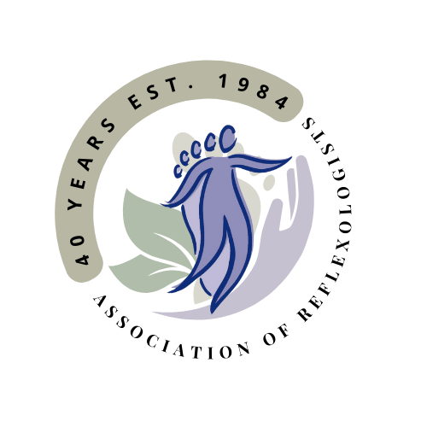Business Terms & Conditions

**Terms and Conditions for Sole Heaven Stoke Gabriel**

I am a full member of the Association of Reflexologists (AoR). Being a full member of the AoR demonstrates that I have completed a quality, nationally recognised Diploma in Reflexology and have support from the AoR.

**As an AoR member:**

* I am bound by the AoR Code of Practice and Ethics.
* I follow the AoR Good Practice Policy and hygiene guidance to ensure client safety.
* I will always be adequately insured for medical malpractice /professional indemnity requirements. The industry standard is in excess of £5 million cover.
* I comply with the AoR Continuing Professional Development requirements which ensures the practice is kept up to date, and always learning new modalities.
* I am compliant with GDPR data protection, please see the separate Privacy policy. Your information will remain confidential at all times.
* As a professional and highly qualified reflexologist with AOR status, I will provide you with the appropriate bespoke treatment and support.

**1. Appointments**

* When making an appointment you agree to the Terms and Conditions.
* When making the appointment you agree to a consultation with me prior to the treatment and you will disclose any relevant medical or lifestyle information.
* I have the right to refuse treatment if a health questionnaire is not completed.
* I have the right to refuse treatment if I feel threatened in any way, even if payment has already been made.
* In return I will apply these high standards to myself. Should I feel unwell, unable to treat or it is inadvisable for me to treat, I will explain the situation to you as soon as possible before your treatment.
* Please arrive for your treatment at the allocated time. If you are a few minutes late, don’t panic. But please try and be respectful of my time – arriving more than a few minutes early is not necessary, and you may be turned away. I sometimes only have a short break between clients which are needed for cleaning, and privacy of each client.
* If you have a cough, a fever or loss of taste and smell or have been in touch with anyone with these symptoms please contact me as we may need to postpone your appointment.
* If you present with any condition or symptom which could be a contraindication, I reserve the right to postpone our treatment until medical advice is sought.
* Fees are either payable in advance as part of a treatment package or in full at the time of treatment. *E.g. I offer buy 6 treatments (£270) and get a 7th free. Payment due upfront prior to first treatment* and are non-refundable

I reserve the right to choose to use discretion regarding the application of any discounts. If money is tight, please ask for concession

**2. Fees**

* The fees are as follows, they are payable in full at the time of treatment.
* Payment can be made in cash, by BACS transfer or cheque.
* List of charges for all treatments: 30mins = £30 45 mins = £40 60mins = £45
* 90 mins =£65
* Gift vouchers can be purchased at the same price as all treatments and are non-refundable. They must be used within 6 months of purchase. They can be posted for a small fee.

**3. Cancellation Policy**

* I have a 24 hour cancellation policy. As you are aware the business is dependent on the number of clients I can see in the clinic hours. Therefore, if you are unable to make a previously arranged appointment, I request that you provide me with at ***least 24 hours notice***. This will allow me the option to re book the time slot with someone on the waiting list.
* Less than 24 hours notice may result in a fair-use fee of the usual treatment cost; i.e. what you would have paid for the treatment, unless there are exceptional circumstances which prevent you from informing me earlier. This fee will be required to be settled prior to any future bookings.

**4. Deposits**

I request a deposit of 50% of the usual appointment fee from **new**clients. Appointments made under this deposit scheme are able to be rescheduled with more than 24 hour notice. Changes or cancellations less than 24 hours notice the deposit will be withheld as stated in the cancellation policy above.

**7. Use of background music**

* I only play Royalty free music within the business and therefore I am not required to have The Music License. Unless you are in your own home, I am unable to play your preferred music selection due to UK laws.